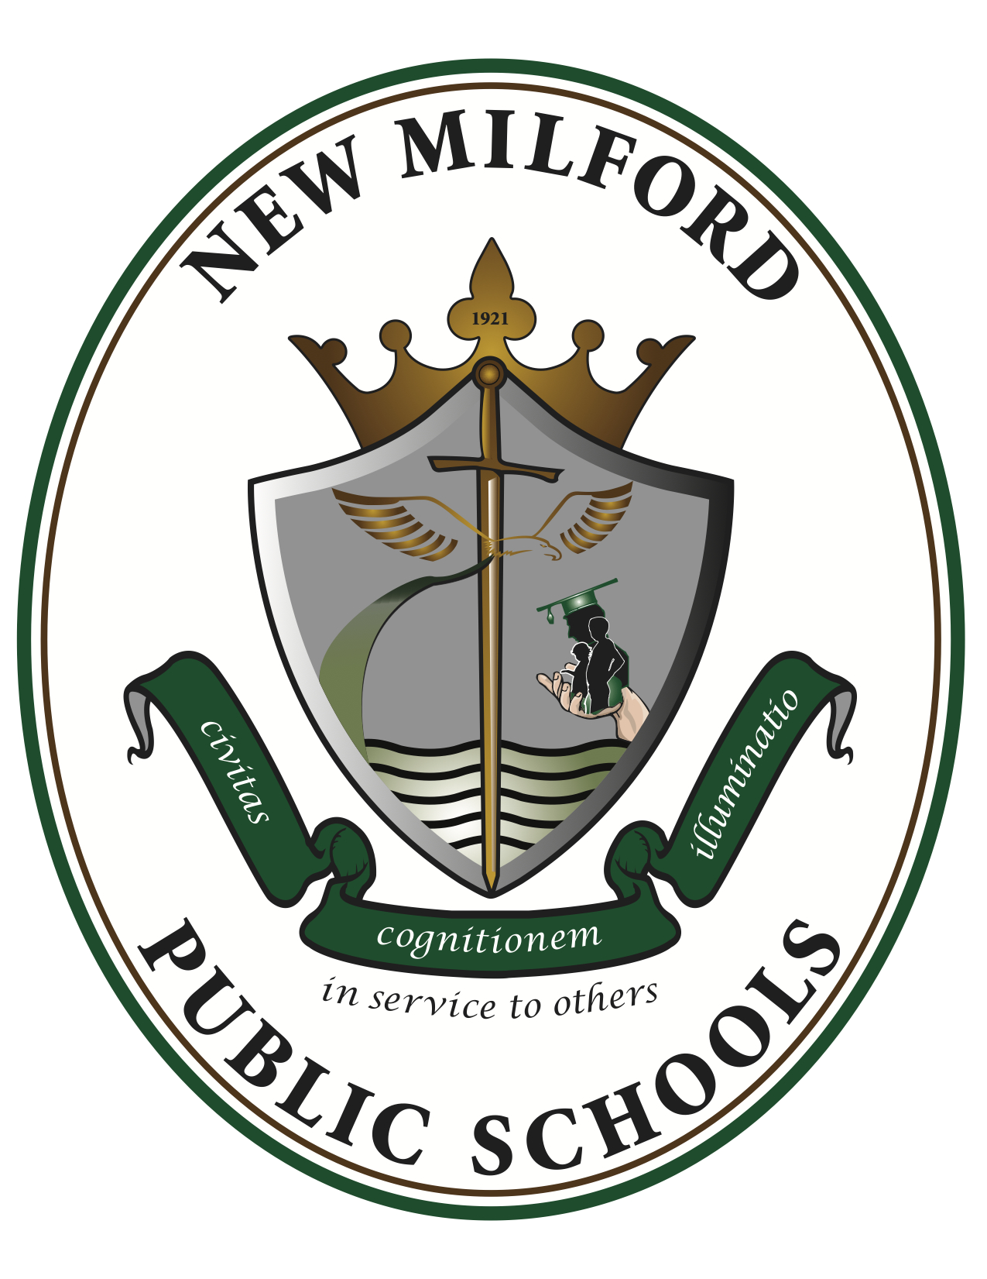

Mandarin II
2023-2024
Room 329

Instructors: Mrs. Weng-Kirschner (Weng Laoshi) skirschner@nmpsd.org

- Course Overview:
Mandarin II is a communicative course for high school students continuing their Chinese language studies.

There are two instructional components, culture and language, both aligned with the six themes of AP requirements. The cultural instruction is theme-and-project-based, organized around discovering common Chinese geography and comparing it to the American one. This part serves the purpose of building the student’s knowledge of Chinese geography. Students are guided by the cultural essential questions to form groups and select themes to work on the project on their own. Language learning continues with twelve daily scenarios belonging in four units that are presented in the second volume of Discovering Chinese Pro series. Of the four language skills listening, speaking, reading and writing, emphasis is placed on speaking and the development of grammar, with special instruction continuously directed into recognizing and writing 120-150 HSK (the international Chinese Proficiency Test that is world widely used, aka Hanyu Shuiping Kaoshi, abbreviated as HSK) level 2 characters through character structure analysis, origin story research and TPRS. The ability to recognize and write HSK level 2 characters is essential for keeping on constructing a solid foundation for the future Chinese learning. The three modes of communication (interpretive, interpersonal, presentational) and the study of the cultures of Chinese-speaking people are integral parts of the course. The Novice-High proficiency levels and sublevels of NCSSFL-ACTFL can-do benchmarks and indicators are used to assess students’ progress throughout the year. The benchmarks for this course are also to prepare the second year Mandarin students to sit for the international HSK 2 test, should they choose. The course curriculum reflects both state and national standards for world language learning.

- Course Objectives:
Mandarin II –
Students will:
exchange some personal information.
- I can ask and say a home address and email address.
- I can ask and say someone’s nationality.
- I can ask and talk about family members and their characteristics.
- I can ask and talk about friends, classmates, or teachers.
exchange information using texts, graphs, or pictures.
- I can ask about and identify familiar things in a picture from a story.
- I can ask about and identify important information about the weather using a map.
- I can ask and respond to simple questions about dates, times, places, and events on schedules.
- I can respond to simple questions based on graphs or visuals that provide information containing numbers or statistics.
interact with others in everyday situations.
- I can order a meal.
- I can make a purchase.
present information about my life using phrases and simple sentences.
- I can describe my family and friends.
- I can describe my school.
- I can describe where I work and what I do.
tell about a familiar experience or event using phrases and simple sentences.
- I can tell what I do in class or at work.
- I can tell about what I do during the weekend.
present basic information about a familiar person, place, or thing using phrases and simple sentences.
- I can describe a landmark, vacation location, or a place I visit.
- I can talk about a famous person from history.
present information about others using phrases and simple sentences.
- I can talk about others’ likes and dislikes.
- I can talk about others’ free-time activities.
- I can give basic biographical information about others.
give basic instructions on how to make or do something using phrases and simple sentences.
- I can tell how to prepare something simple to eat.
- I can describe a simple routine, like getting lunch in the cafeteria.
present basic information about things I have learned using phrases and simple sentences.
- I can present a topic from a lesson based on pictures or photos.
- I can present information about something I learned in a class or at work.
write information about my daily life in a letter, blog, discussion board, or email message.
- I can introduce myself.
- I can describe my family and friends.
- I can describe my school.
- I can describe where I work and what I do.
write short notes using phrases and simple sentences.
- I can write a postcard message.
- I can write a special occasion message such as a birthday or congratulatory note.
- I can write a short announcement, invitation, or thank-you note.
write about a familiar experience or event using practiced material.
- I can write what I do in class or at work.
- I can write what happens after school or during the weekend.
- I can write about a website, a field trip, or an activity that I participated in.
write basic information about things I have learned.
- I can write up a simple process like a science experiment
- I can write about a topic from a lesson using pictures or photos.
- I can write about something I learned online, in a class, at work, or in the community.
ask for information in writing.
- I can request an appointment with a classmate, teacher, or colleague.
- I can request an application for a job, membership in a club, or admission to a school or program.
sometimes understand simple questions or statements on familiar topics.
- I can recognize the difference between a question and a statement.
- I can sometimes understand questions about how old I am, where I live, what I do in my free time, etc.
- I can sometimes understand questions or statements about family.
understand simple information when presented with pictures and graphs.
- I can understand some facts about the weather when weather symbols are used.
- I can understand when someone describes physical descriptions from a photo or an art work.
- I can follow along with simple arithmetic problems when I can see the figures.
sometimes understand the main topic of conversations that I overhear.
- I can sometimes understand if people are referring to me.
- I can sometimes understand if people are talking about their homes or asking for directions.
- I can sometimes understand a simple transaction between a customer and a sales clerk.
usually understand short simple messages on familiar topics.
- I can understand basic familiar information from an ad.
- I can sometimes identify the purpose of a brochure or poster.
- I can understand simple information in a text message from a friend.
sometimes understand short, simple descriptions with the help of pictures or graphs.
- I can understand simple captions under photos.
- I can understand very basic information from a real estate ad.
understand simple everyday notices in public places on topics that are familiar to me.
- I can understand a simple public transportation schedule.
- I can understand notices that tell of street or metro closings.
- I can understand a store’s hours of operation.
- I can read the labels on a recycling bin.

- Texts and Required Materials:
- Li-hsiang Yu, James P. Lin, Discovering Chinese Pro App Companion Textbook, Workbook, Vol. 1-2, Better Chinese, Palo Alto, CA, 2010.

- Li-hsiang Yu and James P. Lin, Discovering Chinese Pro, Online Course, Better Chinese, Palo Alto, CA, 2010.
- Assorted posters
- Authentic materials

- Grading:
Project/Test/Quiz: 90%
Homework/Classwork/Participation: 10%

- Course pacing:

Mandarin II － PACING GUIDE

Units of Study | Sep |  | Oct |  | Nov |  | Dec |  | Jan |  | Feb |  | Mar |  | Apr |  | May |  | Jun
Unit 1: Physical Attributes
Unit 2: Preferences & Abilities
Unit 3: Activities
Unit 4: Weather & Transportation

- How to build up language skills:
- Vocabulary games
- At the beginning of the class, read out loud / ROL
- During class time, frequently use “turn and talk” practice to build interpersonal speaking skill
- During class, use flip.com to build interpersonal and presentational speaking skills through working on assigned work, especially cultural projects
- Out of class, use flip.com to extend building interpersonal and presentational speaking skills through doing differentiated learning

- How to build up cultural experiences:
- We are a proud member of the New Jersey Chinese Teacher Association
- Celebrate Chinese holidays and traditions in class, school and the Chinese communities
- Do Chinese cultural projects in class, school and the Chinese communities
- Collaborate with other high school Mandarin Chinese
- Collaborate with sister classes from China
- Take China trip to China

