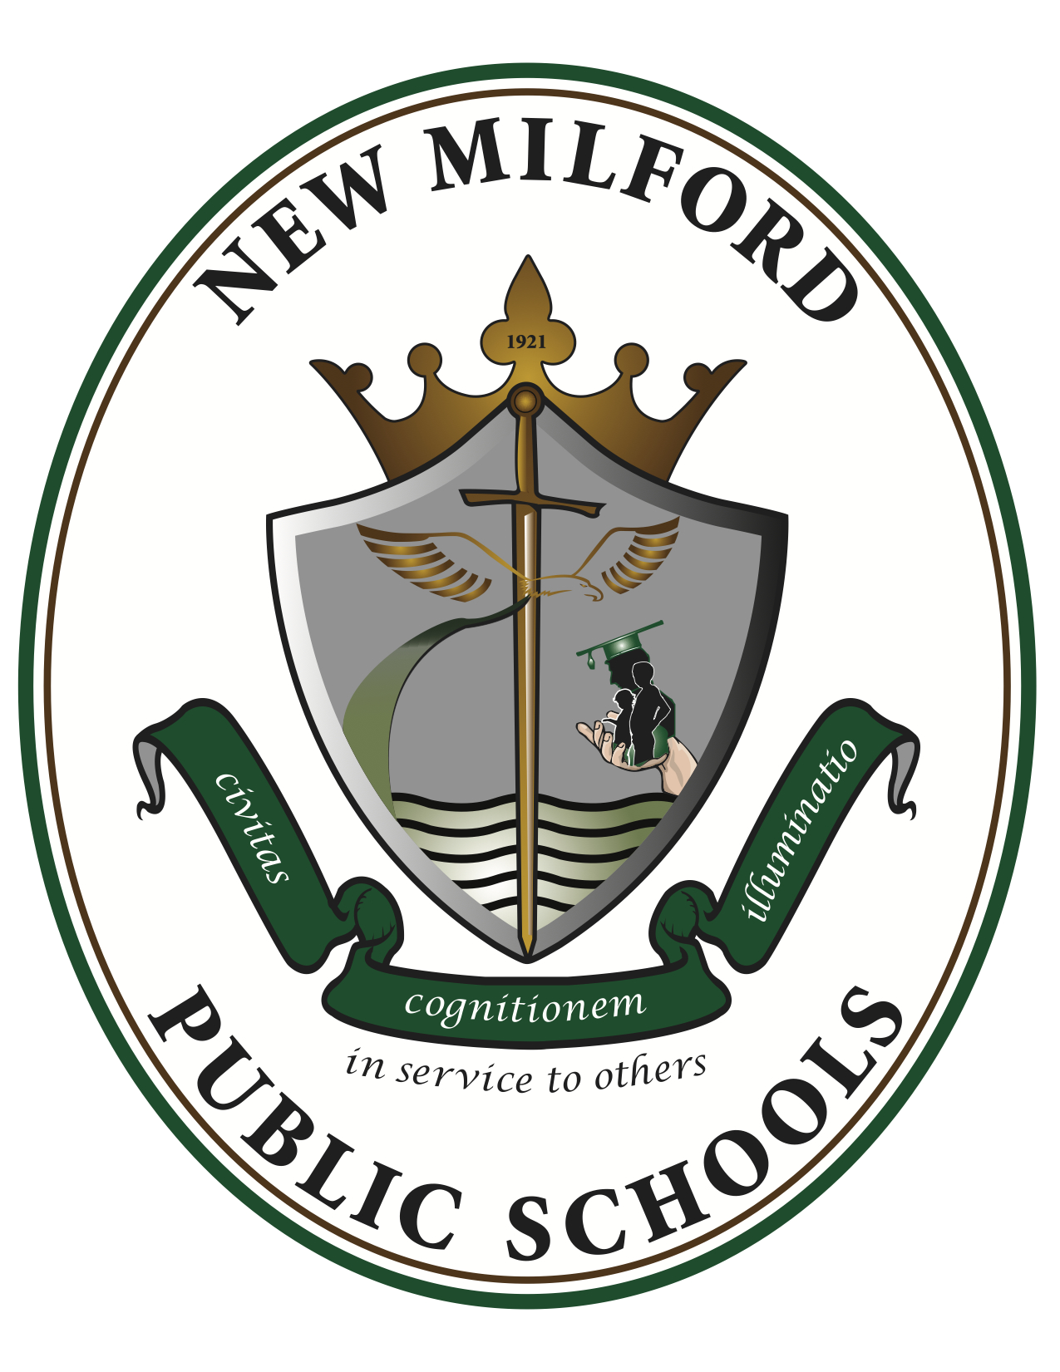

Honor’s Tomorrow’s Teachers
2023-2024
Room 318

Instructor: Mrs. Yager jyager@nmpsd.org
Course Description: This course is focused on the presentation of the realities of teaching and the role of education in society. Issues of social justice and equity are focal points, integrated into discussions about diversity, the purpose of schools, student life, law and ethics, and teacher effectiveness. This course presents information on teacher dispositions, national/state standards, differentiated teaching strategies, family/school connections, learning environment, and classroom management. There is a 10-hour classroom observation component in a K-8th grade classroom.
Student Learning Outcomes:
The students will …
1. evaluate professional and academic standards, learning environments, prevention of HIB, various learning abilities and assets, family/school connections, and inquiry based pedagogies.
2. examine the history of education, cultural and linguistic diversity, multiculturalism, bilingualism, and diverse learning styles of K-8 students.
3. demonstrate the characteristics of cultural self-awareness and develop the skill of self-reflection.
4. evaluate and describe the characteristics of a highly effective teacher that expresses the student’s views on the value of professional dispositions, best practices in teaching and learning, and the teacher's role in building a learning environment that supports the learning of all children, regardless of ability, gender, and/or cultural, ethnic or linguistic diversity.
5. demonstrate the ability to utilize observational data and analysis of classroom procedures from the 10-hour school observation to identify, analyze and write about
the contextual factors which inform the teacher’s decisions in instruction and classroom management; citing specific instances of teacher and student behavior and references to the textbook.
6. advance academic writing, presentation and technological literacy skills.
Means of Assessment:
1. A personal presentation on the characteristics of a highly effective teacher that incorporates academic vocabulary, and expresses the student’s views on the value of professional dispositions, best practices in teaching, learning, and the teacher's role in building a learning environment that supports the learning and positive social interactions of all children, regardless of ability, gender, and/or cultural, ethnic or linguistic diversity.
3. Conduct and present a professional interview of a certified public school teacher.
4. Create and present written lesson plans in the form of presentations, models, and viewbooks

2. Classroom Journal Essay based upon 10-hour observation in a classroom and identifying community, school, classroom and student factors which inform instructional and classroom management decisions, referencing the textbook, using academic language and the language of the discipline.
3. Conduct and present a professional interview of a certified public school teacher.
5. Research a current topic related to education and create a visual presentation using available technology.
6. Utilize academic vocabulary, strong writing skills and the language of the discipline in all writing assignments.
Course Content:
1. Academic vocabulary: in writing to learn exercises, use of terms specific to general education in the areas of professional and K-8 academic standards, teacher dispositions, learning environments, family-school connections, gradual release and inquiry-based pedagogy, and cultural and linguistic diversity
2. Nature of teaching – professional dispositions, ethics, and teaching standards 3. Teacher/student interactions - the teacher’s role in managing instruction and the learning environment with attention to the multiple influences on children’s development and learning
4. Harassment, Intimidation and Bullying (HIB) – the legal definition and individual district policies and procedures on bullying, contributing factors to HIB and prevention strategies including social-emotional learning, ecological issues, characteristics relating to bullying, identification of groups more prone to being bullied, and differentiated interventions,
5. Academic standards – Student Learning Standards, Next Generation Science Standards, and NJ Preschool Teaching and Learning Standards
6. Teaching and learning – how students learn, active learning techniques, multiple intelligences, engaging students, grouping, whole group vs small group planning, Universal Design for Learning for differentiating within a lesson, asking questions (Bloom’s taxonomy and Webb’s Depth of Knowledge), open vs. closed questions, closure, teaching for understanding
7. Student engagement - the effect upon learning environments of educational resources, technology, higher level questioning, inquiry-based and active learning, and constructivist teaching strategies furthering student engagement and interests
8. Diversity - the influence of cultural and linguistic diversity upon the teaching/learning process
9. Family/school connections – nurturing partnerships with families, including those from culturally and linguistically diverse backgrounds, that will enhance academic and social-emotional outcomes of P-12 students
10. Acquire the academic vocabulary associated with the knowledge and understanding of the topics presented in this course.

Teaching/Learning Methods:
• Lecture and discussion
• Small group interactions in class
• Experiential learning (10 hours classroom observation)
• Interactive hands-on pedagogies
• Multimedia lesson plan presentations
• Websites on current topics (e.g. HIB, state-wide achievement testing, family school connections)
Course Grade Determination:
Writing/Presentations 40%
Reading 30%
Speaking/Listening 20%
Homework/Classwork 10%

Course Outline and Calendar: Subject to change
Marking Period 1 Topics | Becoming a Teacher
 | History of Education
 | Student Diversity
 | Differentiated Teaching Strategies
Marking Period 2 Topics | Engaging Your Diverse Students
 | Student Life at School and at Home
 | Purposes of America’s Schools
 | Curriculum, Standards and Testing
Marking Period 3 Topics | Effective Collaborative Planning
 | Traditional Philosophies of Education
 | Current Issues: HIB Policies
Marking Period 4 Topics | Financing and Governing America’s Schools
 | School Law and Ethics
 | Reflective Teaching

