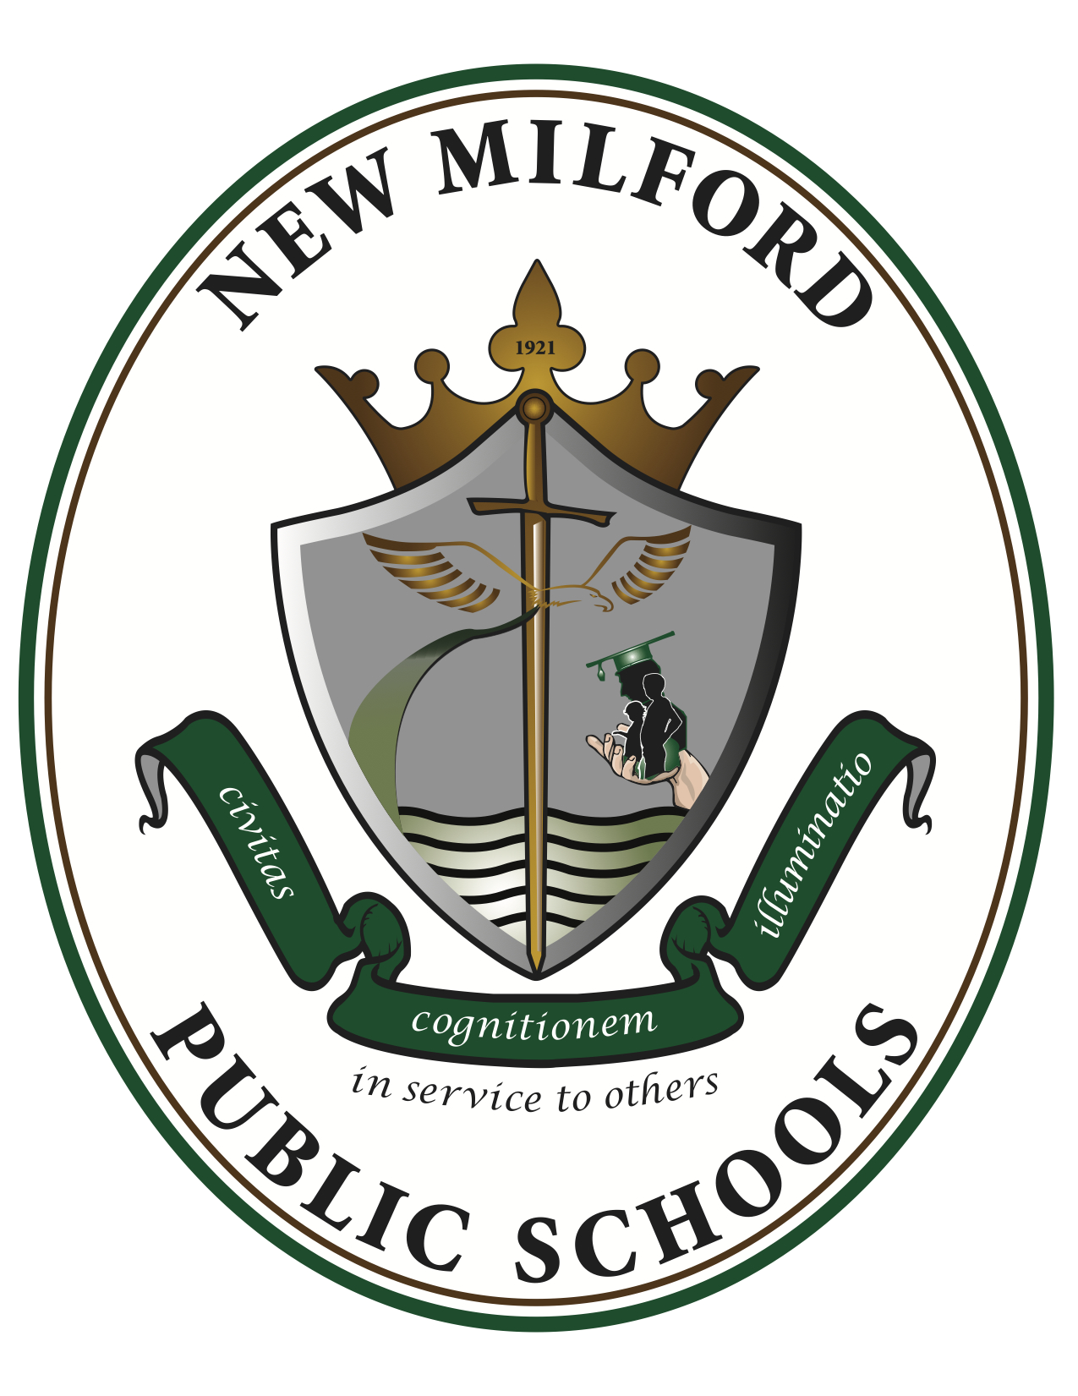

12th Grade CP English
2023-2024
Room 318

Instructors: Mrs. Yager jyager@nmpsd.org

- Course Overview:
- The purpose of the course is to expose the learner to the philosophy, arts and literature of many cultures around the world—including the student’s own heritage. It is hoped that the learner will integrate the power of a culture’s literature, art, and belief system to stimulate an ongoing curiosity and a critical response. It is further hoped that students will learn about the world and its peoples and will teach their own classmates about their own personal heritage and culture. It is further intended that as a result of their exposure, reading and responding, the students will recognize and appreciate the human element of a culture (as opposed to the scientific side) and, as such, broaden their exposure to and acceptance of various human beliefs and behaviors culminating in a philanthropic view of the world and a better understanding of themselves

- Course Objectives:
- Students will cite strong and thorough textual evidence from literary texts and make relevant connections to support analysis of what the text says explicitly as well as inferences drawn from the text;
- Students will determine two or more themes or central ideas of a text and analyze their development over the course of the text;
- Students will analyze how complex characters or people develop over the course of a text, interact with other characters, and advance the plot or develop ideas;
- Students will determine the meaning of words and phrases as they are used in the text and interpret the significance of the author's choices in terms of structure and plot devices;
- Students will analyze multiple interpretations of a story, drama, or poem evaluating how each version interprets the source text;
- Students will write arguments to support claims in an analysis of substantive topics or texts, using valid reasoning and relevant and sufficient evidence;
- Students will write narratives to develop real or imagined experiences or events using effective technique, well-chosen details, and well-structured event sequences;
- Students will conduct short as well as more sustained research projects to answer a question or solve a problem; narrow or broaden the inquiry when appropriate; synthesize multiple sources on the subject, demonstrating understanding of the subject under investigation;
- Students will initiate and participate effectively in a range of collaborative discussions with peers on grade appropriate topics, texts, and issues, building on others’ ideas and expressing their own clearly and persuasively;
- Students will demonstrate command of the conventions of standard English grammar and usage when writing or speaking; and
- Students will demonstrate command of the conventions of standard English capitalization, punctuation, and spelling when writing.

- Texts and Required Materials:
- Prentice Hall World Masterpieces. Simon and Schuster, 1992. Print.
- Assorted novels and non-fiction
- Assorted poems and short stories

- Grading:
Writing 40%
Reading 30%
Speaking/Listening 20%
Homework/Classwork 10%

12th Grade CP English
Course Outline

Units of Study | Sep |  | Oct |  | Nov |  | Dec |  | Jan |  | Feb |  | Mar |  | Apr |  | May |  | Jun
Unit 1: Origins and Identity
Core - College Essay
Unit 2: The Middle East
Core - Excerpts from the Qur’an
Unit 3: Europe
Core - Othello
Unit 4: Africa
Core - Chinua Achebe Short Stories
Unit 5: Asia
Core - Ancient Chinese Readings
Unit 6: Latin & South America
Core - Poetry

